As part of the funding agreement under the Colac Otway Shire Grants Program, you are required to submit photographs of your completed project or event.

*Colac Otway Shire Grants Program*

Celebrate your success with Photographs

From time to time, we like to use some of the submitted photographs in promoting the Grants Program and/or community events and projects. During the Acquittal process you will be able to indicate if you do not wish your photographs to be used in any marketing or promotions.

We have put together a few tips for submitting great photographs:

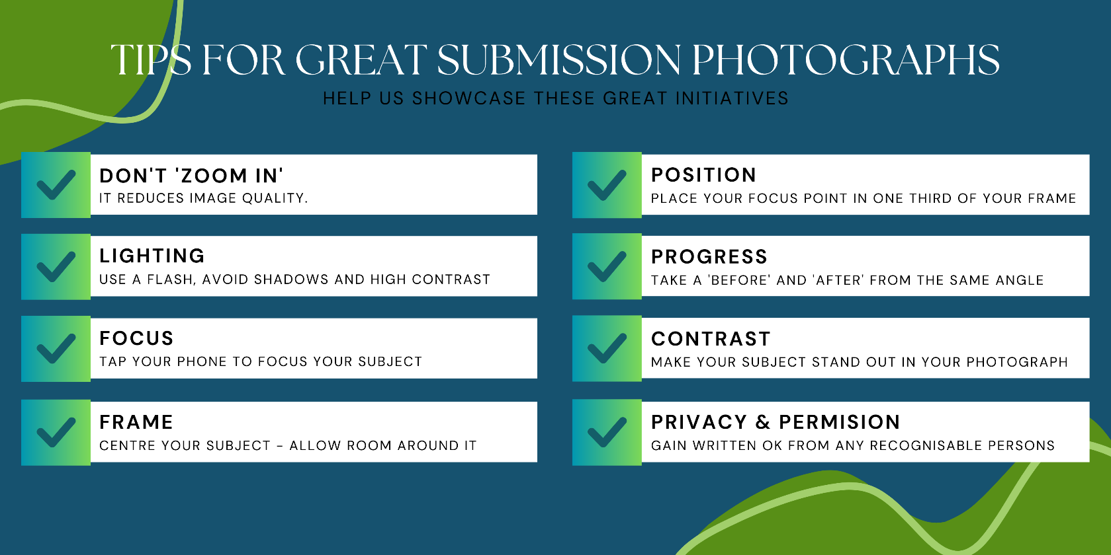

You can submit multiple photographs, so have a play at being a photographer and submit your best ones.

Photos tell a fantastic story of what you have achieved.

These may be shown to the community at the annual grant’s presentation function and on Council’s website or social media.

**Where can I get more info?**If you have further questions about the photographs you will submit along with your Acquittal, contact the Grants Officer, inq@colacotway.vic.gov.au or by telephone 5232 9400.